**Lab Steps**

**Task 1: Sign in to AWS Management Console**

Enter your **Username** and **Password** (**IAM Username and Password)** in AWS Console and click on the **Sign-in** button.

Once Signed In to the AWS Management Console, make the default AWS Region as **US East (N. Virginia) us-east-1.**

**Task 2: Launching an EC2 Instance**

In this task, we are going to create an EC2 instance, which will serve as one of the targets for the Network Load Balancer

1. Make sure you are in**US East (N. Virginia) us-east-1**Region.
2. Navigate to EC2 by clicking on the **Services** menu in the top, then click on **EC2** in the **Compute** section.
3. Click on **Instances** from the left sidebar and then click on **Launch instances**button.

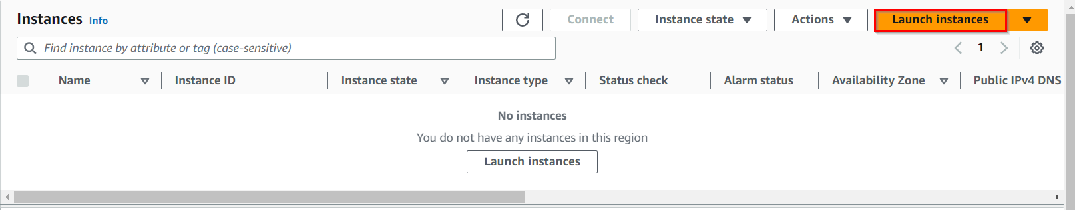

1. Name : Enter **NLBEC2server**

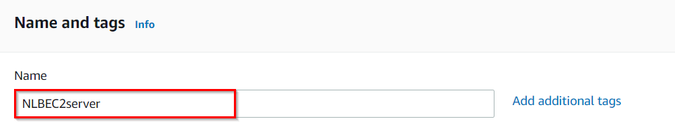

1. **For Amazon Machine Image (AMI):** In the Quick Start menu, select **Amazon Linux AMI**
2. **For Instance Type:** select ***t2.micro***



1. **For Key pair:** Select **Create a new key pair** Button
   * Key pair name: **MyNLBKey**
   * Key pair type: **RSA**
   * Private key file format: **.pem**
2. Select **Create key pair** Button.
3. In Network Settings, Click on **Edit**:

* Auto-assign public IP: **Enable**
* Select **Create new Security group**
* Security group name : Enter **NLBserver-SG**
* Description : Enter ***Security Group to allow traffic to EC2***
* To add**SSH**
  + Choose Type : Select **SSH**
  + Source : Choose **Anywhere**
* For **HTTP**, click on **Add security group rule**.
  + Choose Type : Select **HTTP**
  + Source : Choose **Anywhere**
* **For Nginx,**Click on**Add security group rule.**
  + Choose Type : Select **Custom TCP Rule**
  + Port Range : Enter ***8080***
  + Source : Choose **Anywhere**



1. Expand **Advanced Details.**
2. Under the **User data** section, copy and paste the below code. This code installs Apache Server and also creates a web page.

|  |
| --- |
| #!/bin/bash  #Switch to root user  sudo su  #Update the system packages  yum update -y  #Install Apache HTTP Server  yum install httpd -y  #Start the Apache service  systemctl start httpd  #Enable Apache to start on system boot  systemctl enable httpd  #Create an index.html file with a custom response  echo "<html> <h1> Response coming from server </h1> </html>" > /var/www/html/index.html  #Restart the Apache service for changes to take effect  systemctl restart httpd |

**Note: After pasting the user data, make sure to remove extra spacing.**

1. Keep rest thing Default and Click on **Launch Instance** Button.
2. Select **View all Instances** to View the Instance you Created
3. **Launch Status:** Your instances are now launching, Navigate to **Instances** page from left menu and wait the status of the EC2 Instance changes to running
4. Now in the EC2 dashboard, you can see the instance is running as shown below:

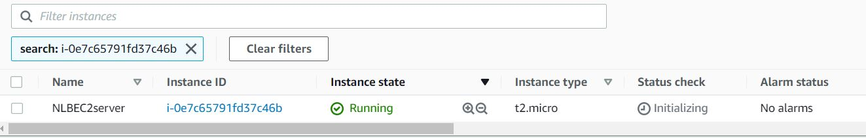

**Task 3: Creating Network Load Balancer**

In this task, we are going to create a Network Load Balancer (NLB) in AWS. The NLB distributes incoming traffic across multiple targets (in this case, the EC2 instance created in the previous task).

1. Navigate to **Load Balancers** from the EC2 left menu bar under the sub-heading **Load Balancing**.
2. Click on the **Create Load Balancer**button.

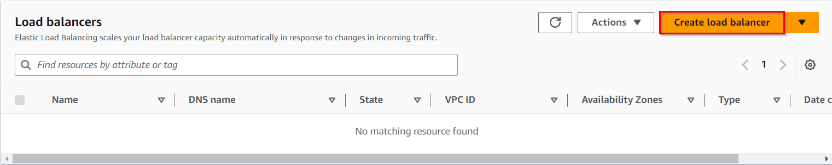

1. **Select Load Balancer Type**: Under the **Network load balancer**, click on **Create** button.



1. The next five screens will require configuration modification from the default values provided. If a field is not mentioned, leave it as default or empty.

* **Configure Load Balancer:**
  + Name : Enter **MyNetwork-LB**
  + Scheme : Select **internet-facing**
  + VPC : Select **default VPC**
  + Mappings : **Select all available zones** using a checkbox.
* **Security groups:**
  + Select **NLBserver-SG**security group which we created while launcing EC2
* **Listeners and routing:**
  + Load Balancer Protocol : Select **TCP**
  + Load Balancer Port **:**Choose**80**
  + Default action : **Create target group**



* Choose a security group: **default**

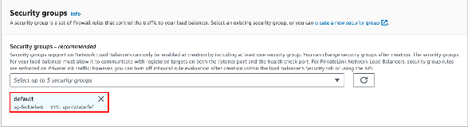

* Choose a target type: **Instances**
  + Target group name: Enter ***Apache-TG***
  + Protocol: Choose **TCP**
  + Port: **80**
  + Click **Next**
  + Select **NLBEC2Server** and select **Include as pending below** button
  + Click **Create target group** button
  + Ignore the warning message and click **Continue**
  + Now we can see **Apache-TG** target group created.
* Now go back to the **Load Balancers** tab, and select **Apache-TG** in **Default Action** in **Listeners and routing.**
* Click on Refresh button if target-group is not visible
* Click on **Create load balancer** button
* Click on **View Load Balancers**
  + After 1–2 minutes, the state will change to **active** and is ready.

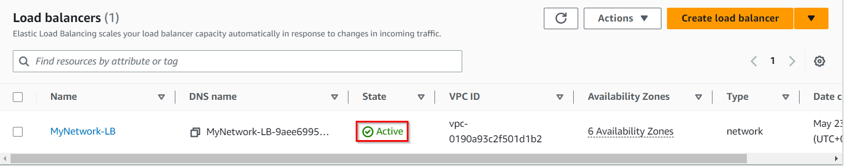

**Task 4: Create Target Group for Nginx**

In this task, we are going to create a target group specifically for the Nginx service running on the EC2 instance.

1. Navigate to **Target Groups** available in the left menu of EC2 Page. It will be available under the sub-heading **Load Balancing**.
2. Click on **Create target group**

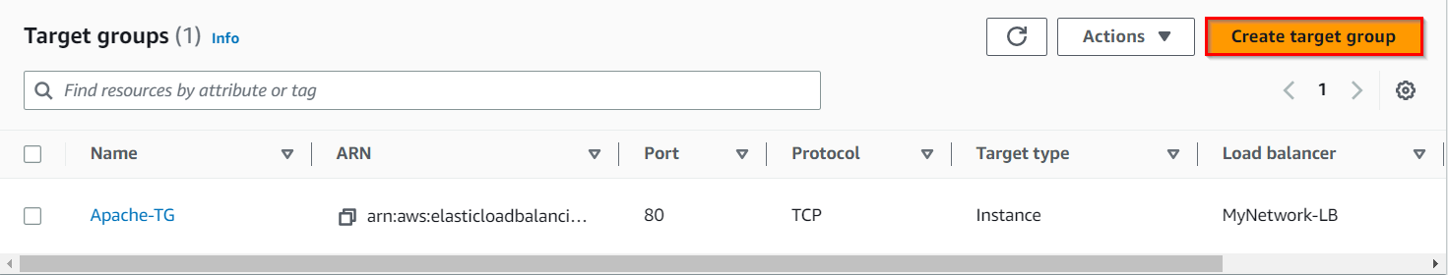

1. In the Create Target Group form Basic configuration:

* Choose a target type: **Instances**
* Target group name : Enter **Nginx-TG**
* Protocol : choose **TCP**
* Port : Enter ***8080***

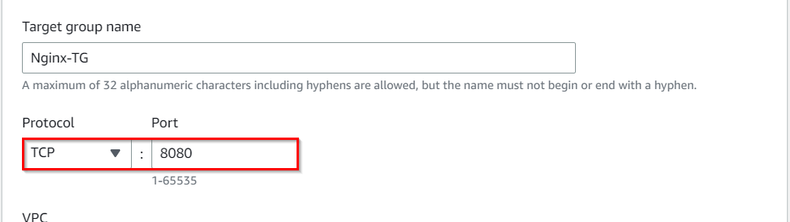

* Leave other settings as default. Click on the **Next** button.

1. Select the **NLBEC2server** and select**Include as pending below**button
2. Click **Create target group**button

**Task 5: Creating a New Listener for Nginx on port 8080**

In this task, we are going to add a new listener to the load balancer, specifically for the Nginx service on port 8080. Listeners define how the load balancer handles incoming traffic and which target group to route the traffic to.

1. Now we need to add a new listener for Nginx to listen for traffic on port 8080.
2. Navigate to the Load Balancer console and select the**MyNetwork-LB.**Click on **Add Listner** as shown below:

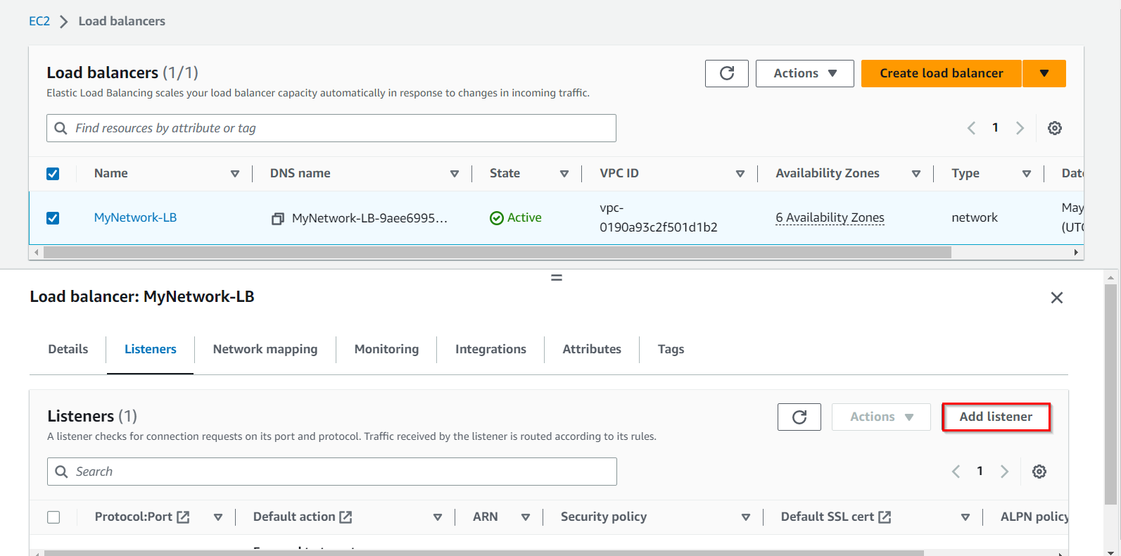

1. Now add the new listener as follows:

* Protocol : Select **TCP**
* Port : Enter **8080**

1. Chose the **Nginx-TG** as shown below:

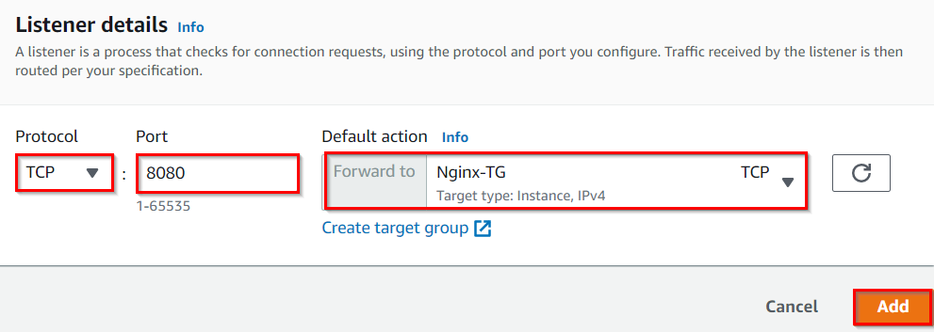

1. Both Listeners will be shown.

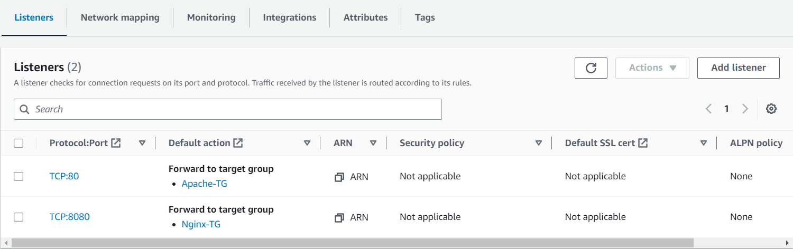

**Task 6: Installing and configuring Nginx**

In this task, we are going to install and configure the Nginx service on the EC2 instance. This task ensures that the Nginx service is running on the specified port (8080) and ready to receive traffic from the load balancer.

1. SSH into the EC2 instance, following the steps in [SSH into EC2 Instance](https://www.whizlabs.com/labs/support-document/ssh-into-ec-instance).
2. Switch to the root user using the command:

sudo su

1. You will see apache is already installed and listening on port 80. To do so, run the following commands:

* To find version:

httpd -v

* To find HTTPD running:

lsof -i tcp:80

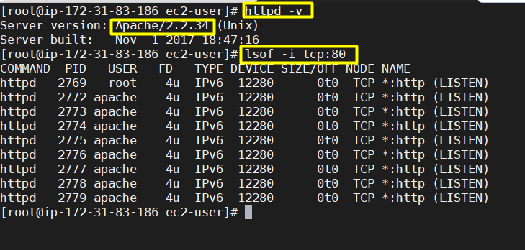

1. Now install **Nginx** using below command:

sudo yum install nginx -y

1. Now we need to change the port number for Nginx service to 8080 because HTTPD service already running on port. To do so, type the following commands:

cd  /etc/nginx

vi  nginx.conf

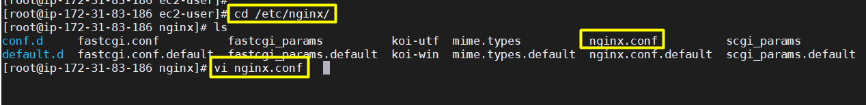

1. Scroll down and edit the 'listen' line to port number 8080. To edit in vi, press **i** to insert. After editing, press **esc** and give command **:wq** which saves the file and quits from vi.

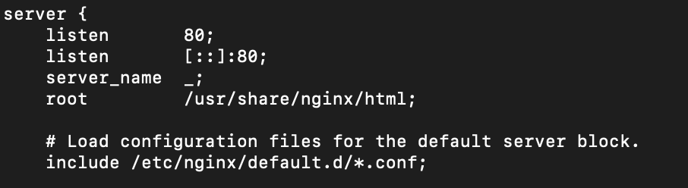

1. Now change the default **port number 80 to 8080**as shown below:

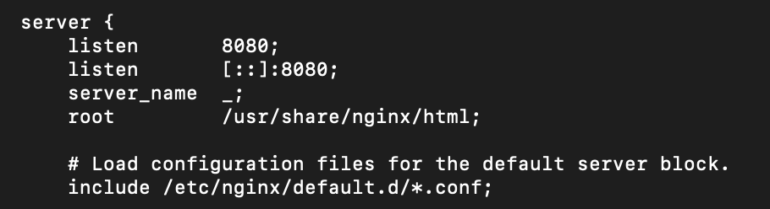

1. Start the Nginx service using the below command:

service nginx start

1. You can check the status of Nginx service using the below command:

lsof -i tcp:8080

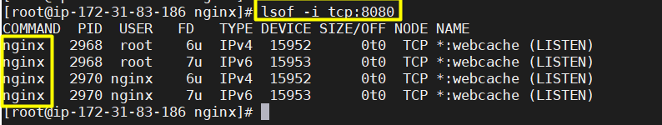

**Task 7: Testing Network Load Balancer**

In this task, we are going to test the Network Load Balancer and verify that it properly distributes traffic to the target groups. By accessing the load balancer's DNS name with the appropriate port, users can check if the Apache and Nginx services respond correctly.

1. Wait 3 to 4 minutes until the**target reaches healthy status** and navigate to the Load balancer console and copy the DNS name. Enter the address in the browser.

* **MyNetwork-LB-0a4ff4cc035bae63.elb.us-east-1.amazonaws.com**

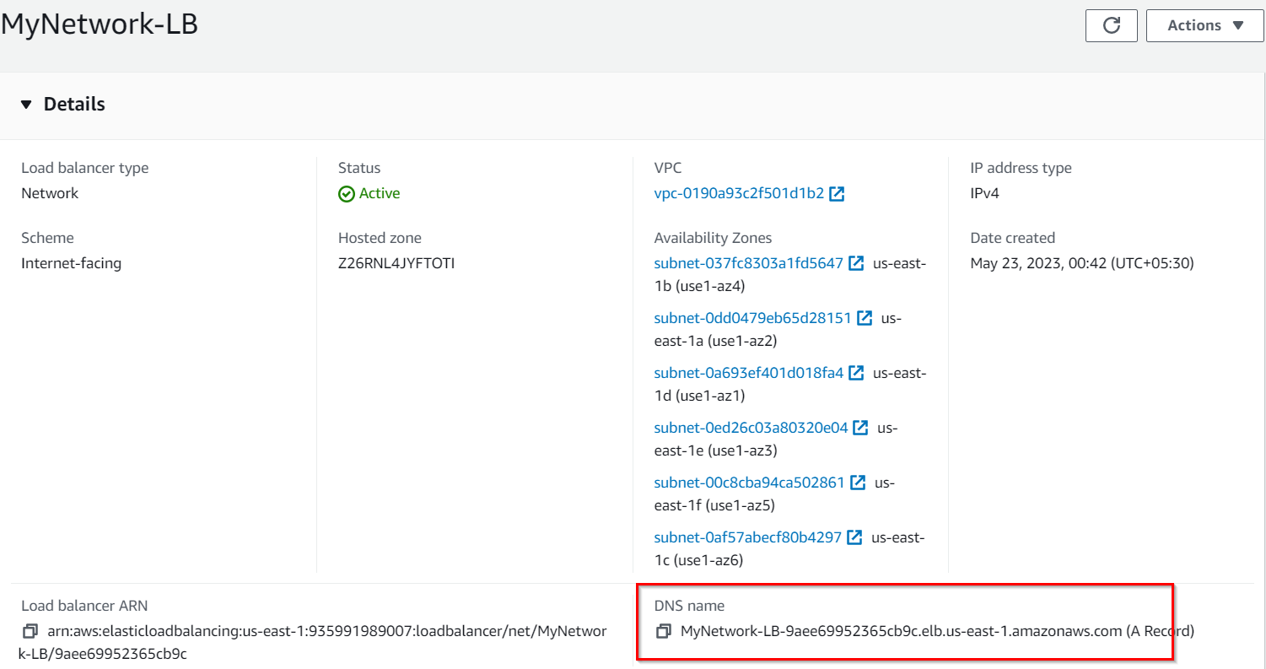

1. You will see the default apache page. **By default network load balancer will route the traffic to port 80**

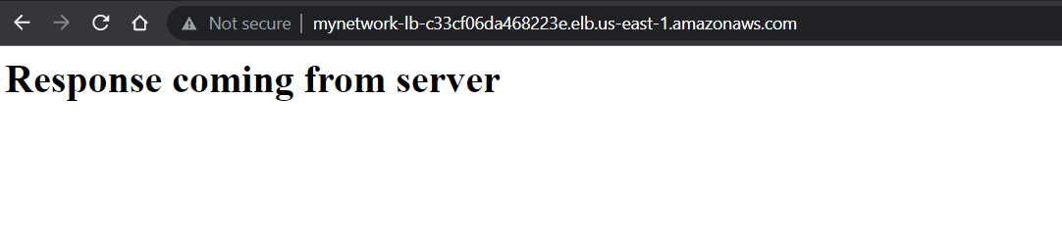

1. Now repeat the above step by appending port number **8080** at the end of load balancer endpoint (as shown below) and you will get the Nginx default page.
   * **MyNetwork-LB-0a4ff4cc035bae63.elb.us-east-1.amazonaws.com:8080**

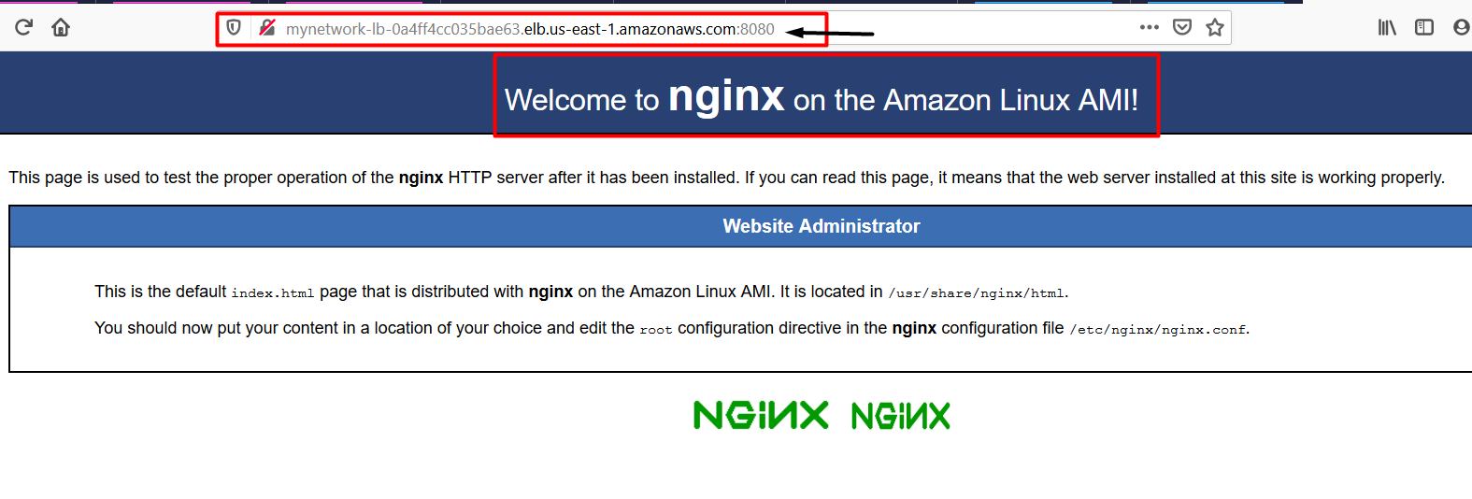

1. From the above steps we have **successfully created the Network load balancer** and routed the traffic to two different services ( Apache and Nginx ) listening on two different ports ( 80 and 8080 ).
2. We have also successfully created and tested the Network Load Balancer.

**Do You Know?**

Network load balancers have an amazing capability to handle millions of concurrent connections. Operating at the transport layer, they efficiently distribute incoming network traffic across multiple backend servers or instances. With advanced algorithms, they ensure optimal resource utilization, high availability, and scalability for applications and services. This capability enables organizations to deliver seamless and responsive experiences to a large number of users.

**Task 8: Delete AWS Resources**

**Deleting Load balancer**

1. In the EC2 console, navigate to **Load balancers** in the left-side panel.
2. **MyNetwork-LB** will be listed here.
3. To **delete** the load balancer, need to perform the following actions:
   * **Select** the load balancer,
   * Click on the **Actions** button,
   * Select the **Delete load balancer** option.
4. Confirm by Entering on the **Confirm** and clicking on Delete button when a pop-up is shown.
5. MyNetwork-LB will be deleted immediately.

**Deleting Target groups**

1. In the EC2 console, navigate to **Target Groups** in the left-side panel.
2. **Apache-TG** will be listed here.
3. To delete the **target group**, need to perform the following actions:
   * **Select** the target group,
   * Click on the **Actions** button,
   * select the **Delete** option
4. Confirm by clicking on the **Yes, Delete** button when a pop-up is shown.
5. Web-server-TG will be deleted immediately.
6. Similarly delete **Nginx-TG**

**Terminate EC2 Instances**

1. In the EC2 console, navigate to **Instances**in the left-side panel.
2. EC2 Instance **NLBEC2Server** will be listed here.
3. To terminate the **EC2 Instances**, need to perform the following actions:
   * **Select** the EC2 instances,
   * Click on the **Instance state** button,
   * select the **Terminate instance** option
4. Confirm by clicking on the **Terminate** button when a pop-up is shown.
5. **EC2 Instances** will be terminated immediately.

**Completion and Conclusion**

1. You have successfully used the AWS management console to create an Amazon EC2 instance.
2. You have created a Network Load Balancer with an Apache Target group.
3. You have created an Nginx Target group and attached the EC2 server to route traffic on port 8080.
4. You tested the Network Load Balancer.